**Before you collaborate**

A little bit of preparation goes a long way with this session. Here’s what you need to do to get going.

#### 15 minutes

**1**

## Define your problem statement

What problem are you trying to solve?Frame you problem as a How might We statement This will be focus of your brainstorm

**5 minutes**

**2**

## Brainstorm solo

Have each participant begin in the "solo brainstorm space" by silently brainstorming ideas and placing them into the template. This "silent-storming" avoids group-think and creates an inclusive environment for introverts and extroverts alike. Set a time limit. Encourage people to go for quantity.

**10 minutes**

**20 minutes**

Category 1

**3**

## Group ideas

**TIP**

You can use the **Voting session** tool above to focus on the strongest ideas.

Take turns sharing your ideas while clustering similar or related notes as you go. In the last 10 minutes, give each cluster a sentence-like label. If a cluster is bigger than six sticky notes, try and see if you and break it up into smaller sub-groups

### Fertilizer Recomentation System for Disease Prediction

**A Team gathering**

Define who should participate in the session and send an invite.Share relevant information or pre-work ahead.

**B Set a goal**

Think about the problem you'll be focusing on solving in the brainstorming session.

### Problem

1. Identify the disease on plants using deep learning techniques and to recommend the fertilizers for reducing the diseases.
2. Provide website information for recommened fertilizer

**ROSY**

User friendly website

Website for fetilizer recommendation

**NANDHINI**

It simplifies the farmers work

Pre-trained model for image classification

# 

It reduces man power

Identify the disease

Smart solution to solve the problem

Determining best fertilizer

**ARULLAKSHMI**

# 

Cost of sing this application is less

Build keras image classification model

They can find the diseases at early stages

Making revolutionary changes in agriculture field

Interactive user interface to upload images

Deep learning based mathematical model for detecting diseases

Improves produtivity

Early detection and management of problem

Interactive user interface to upload images

Better utilization available resources

Identify the disease

Website for fertilizer recommentation

Useful to people with no prior knowledge

Interactive user interface to upload images

Category 2

Deep learning based mathematical model for detecting diseases

Pre-trained model for image classifcation

Cost of using this application less

Making

Interactive user interface to upload images

Portal for farmers

Build keras image classifcation model

Early

Agriculture is the most important sector in today’s

life. Most plants are affected by a wide variety of bacterial and fungal diseases. Diseases on plants placed a major constraint on the production and a major threat to food security. Hence early and accurate identification of plant diseases is essential to ensure high quantity and best quality. In recent

fungal diseases

**ATCHAYA**

|  |  |  |
| --- | --- | --- |
| Fertilizer Recommendation | Instant solution | Useful to people with no prior knowledge |
| Admin can view |  |  |
| the recommended  fertilizer through | It will save time | Portal for famers |
| gmail |  |  |

|  |  |  |
| --- | --- | --- |
| Useful to Farmers | Recommends Fertilizers | Utilizing of resources |
| Simple UI | Reduces the cost | Improves Profit |

|  |  |  |
| --- | --- | --- |
| fungal diseases | Bactariel | major threat |
| food security | high quantity | low quantity |

Category 3

Admin can

Better

revolutionary changes in agriculture feld

detection and management of problem

years, the number of diseases on plants and the degree of harm caused has increased due to the variation in pathogen varieties, changes in cultivation methods, and inadequate plant protection techniques

10 minutes

1-6 Colarborate

**C Interested in learning more?**

### Check out the Meta Think Kit website for additional tools and resources to help your team collaborate, innovate [a**O**n**p**d**en**m**th**o**e**v**w**e**e**i**b**d**s**e**it**a**e**s](https://www.facebook.com/business/m/thinkkit/?ref-northstar) forward with confidence.

**QUESTION**

**How might we... [insert problem statement here]?**

Instant

solution

They can find the diseases at early stages

view the

recommended fertilizer through gmail

Smart solution to solve the problem

utilization of available resources

Cost of using this application is less

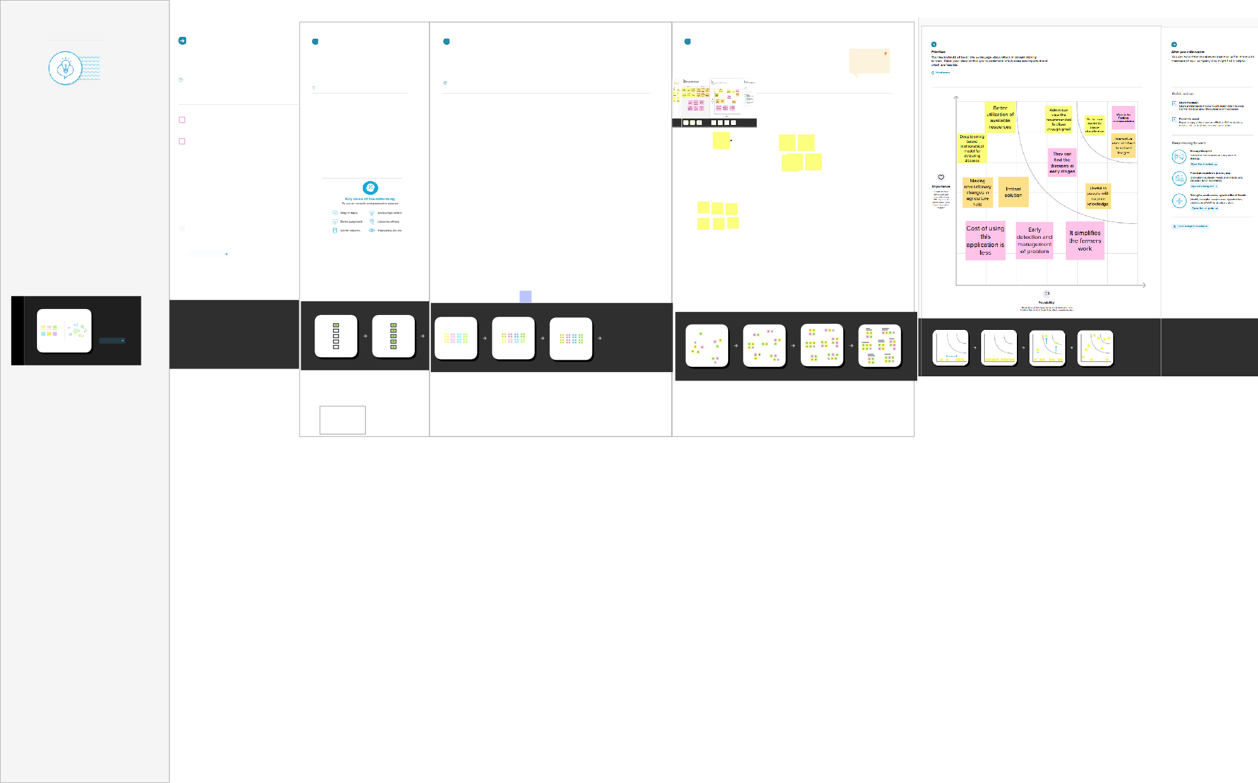

**Need some inspiration?**

See a finished version of this template to kickstart your work.

[**Open example**](https://app.mural.co/template/d42717ab-e2ce-4ebc-a805-b0cccd51479d/0436e888-3331-42fe-8cc7-5028b525622e)

**QUESTION**

**How might we... [insert problem statement here]?**